**1** There are three states of matter. These are solid, liquid and gas. One state can be converted into another.

**a)** What is meant by the change in state of a substance? (1)

**b)** Complete the table below by writing in the correct term which describes each statement. For each statement, say whether the internal energy increases or decreases. The first one has been done for you.

|  |  |  |
| --- | --- | --- |
| Definition | Term | Internal energy |
| Changing a liquid into a solid | Freezing | Decreases |
| When liquid changes into a gas |  |  |
| A solid changing into a gas |  |  |
| When a gas changes into a liquid |  |  |

(6)

**c)** Which of the following changes in state are physical and which are chemical?

**i)** Boiling water

**ii)** Burning toast

**iii)** Cutting a piece of wood

**iv)** Freezing ice cream

**vi)** Frying an egg (5)

**2** If the mass and the volume of an object are known, the density of that object can be calculated.

**a)** The diagram shows a cylinder and a cuboid.

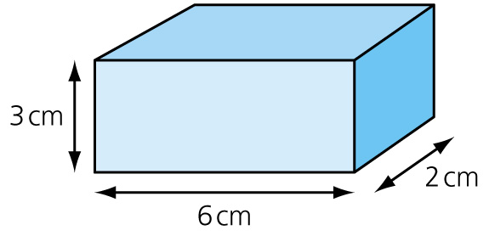  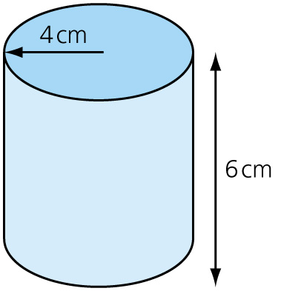

**i)** Calculate the volume of each shape in cm3. (4)

**ii)** The mass of the cylinder is 62 g and the mass of the cuboid is 20 g. Calculate the density of each in kg/m3. (4)

**iii)** From the table, identify the type of material that the cylinder and the cuboid are likely to be made of.

|  |  |
| --- | --- |
| **Material** | **Density in kg/m3** |
| Lead | 11400 |
| Glass | 2500 |
| Lithium | 500 |
| Cork | 200 |

(2)

**iv)** Why is there a difference between the true value and the value that you have calculated? (1)

**b)** The diagram shows a 1000 cm3 measuring cylinder partially filled with water. A stone with a mass of 42 g is dropped into the cylinder.



**i)** Explain how you would use the apparatus accurately to determine the volume of the stone. (3)

**ii)** What is the volume of the stone? (1)

**iii)** Calculate the density of the stone in kg/m3. (2)

**3** **a)** Explain what is meant by:

**i)** specific latent heat (2)

**ii)** specific latent heat of vaporisation. (2)

The graph shows how the temperature of a substance, initially a solid, increases with time as heat is applied. The substance is eventually changed into a gas.

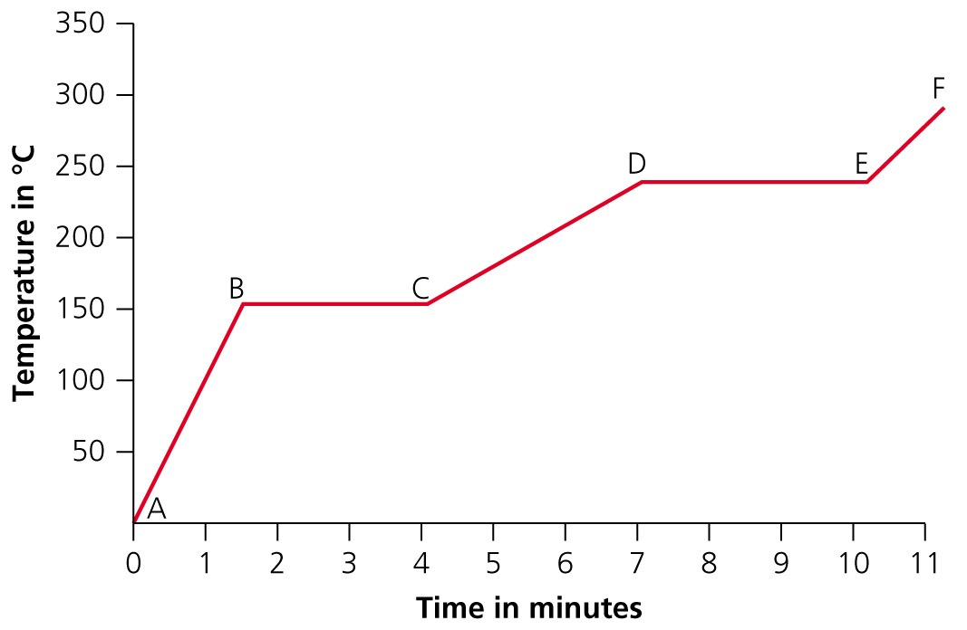

**b)** Explain what is happening:

**i)** between B and C. (2)

**ii)** between D and E. (2)

**iii)** between E and F. (1)

**iv)** At which temperature does the substance melt? (1)

**v)** Which is higher, the latent heat of fusion or the latent heat of vaporisation. Give a reason for your answer. (2)

**4** A container of gas has a fixed volume.

**a)** What happens to the pressure of the gas when the temperature is increased? (1)

**b)** Describe how the molecules or atoms of the gas behave when the temperature increases. (2)

**c)** What happens to the pressure of the gas if the volume of the container is reduced (temperature held constant)? (1)

**d)** Explain your answer. (2)

**5** The apparatus shown can be used to calculate the specific latent heat of fusion of ice. The heater is used to melt the ice.

The ice block has a mass of 10 g.

Z:\01-Word\01-Download\12_DEC\27\Physics\Tech_Art\HTT_4.3_12.eps

**a)** Why should the ice be allowed to reach a temperature of 0°C rather than being used   
straight from a freezer which has a temperature of –14°C? (2)

**b)** The heater is turned on for 1 minute and 10 g of ice melts. The heater has a power of 50 W.

**i)** Calculate the energy supplied by the heater in 1 minute. (2)

**ii)** Calculate the specific latent heat of fusion of ice. Give your answer in joules per kilogram. (2)

**iii)** Give two reasons why the value obtained from this experiment is likely to be inaccurate. (2)

TOTAL = 55

**1** **a)** A change in state is where one form or state of a substance is converted into another form, e.g. solid into liquid. (1)

**b)**

|  |  |  |
| --- | --- | --- |
| Definition | Term | Internal energy |
| Changing a liquid into a solid | Freezing | Decreases |
| When liquid changes into a gas | **Evaporation/boiling** | **Increases** |
| A solid changing into a gas | **Sublimation** | **Increases** |
| When a gas changes into a liquid | **Condensation** | **Decreases** |

(6)

**c)** **i)** Physical

**ii)** Chemical

**iii)** Physical

**iv)** Physical

**v)** Chemical (5)

**2** **a)** **i)** 6 × 2 × 3 = 36 cm3 (cuboid)

3.14 × 42 × 6 = 301 cm3 (cylinder) (4)

**ii)** 20 g = 0.02 kg; 36 cm3 = 36 × 10–6 m3  
density = = 556 kg/m3 (cuboid)

62 g = 0.062 kg; 301 cm3 = 301 x 10–6 m3  
density =  = 206 kg/m3 (cylinder) (4)

**iii)** The cuboid is likely to be cork.

The cylinder is likely to be lithium. (2)

**iv)** The experiment needs to be repeated to calculate a mean; measurements taken are not accurate. (1)

**b)** **i)** Hold the cylinder at an angle so that the stone can slide into the water: the stone will displace the water in the cylinder: the water level rises from 360 to 520; the difference between these is the volume of the stone (3)

**ii)** 520 – 360 = 160 cm3 (1)

**iii)** density =  =  = 262.5 kg/m3 (2)

**3** **a)** **i)** The amount of energy required for 1 kg of a substance to change state at the same temperature. (2)

**ii)** The specific latent heat of vaporisation is the energy needed to change 1 kg of a liquid; into 1 kg of gas at the same temperature. (2)

**b)** **i)** Between B and C: the solid is still taking in heat energy between B and C. The temperature is not changing. This heat energy is being used to change the state of the substance from a solid into the liquid form. (2)

**ii)** D and E: heat energy is still being taken into the substance. Between D and E the liquid is changing from a liquid into a gas. (2)

**iii)** Between E and F: the temperature rises as the gas particles receive more heat energy and convert this to kinetic energy. (1)

**iv)** 155°C (1)

**v)** Vaporisation: it takes longer for the substance to evaporate than to melt. More energy needs to be supplied for evaporation than for melting. (2)

**4** **a)** Pressure increases. (1)

**b)** Increasing the temperature increases the average speed of the particles of gas; the kinetic energy of particles increases. (2)

**c)** The pressure increases. (1)

**d)** The same number of particles of gas in a smaller volume; the particles of gas hit walls of the container more often so the pressure increases (2)

**5** **a)** The specific latent heat of fusion is the energy required to turn 1 kg of ice at 0°C to 1 kg of water at the same temperature (i.e. 0°C).  
If ice at −14°C is being used, the energy used to warm it up to 0°C is also being measured. (2)

**b)** **i)** *E* = *P* × *t*; *E* = 50 × 60 = 3000 J (2)

**ii)** mass of water = 10 g = 0.01 kg  
energy required = 3000 J;

*E* = *mL*;  *L* =  = 300 000 J/kg (2)

**iii)** The heater is also heating the surrounding air; not all the ice will be at 0°C; the external temperature is not controlled and may fluctuate. (2)

TOTAL = 55